# SCHOOL OF SCIENCES

DEPARTMENT OF COMPUTER SCIENCE



# BCA 202-1

# Data Processing with Spreadsheet

# REPORT

*Submitted by:* Submitted to:

*Name*: MANYA BAJAJ *Faculty name*: Prof. VANDANA

*Registration number*: 23215031 *Designation:* Assistant Professor

*Class*: 4BCA A

**DASHBOARD**

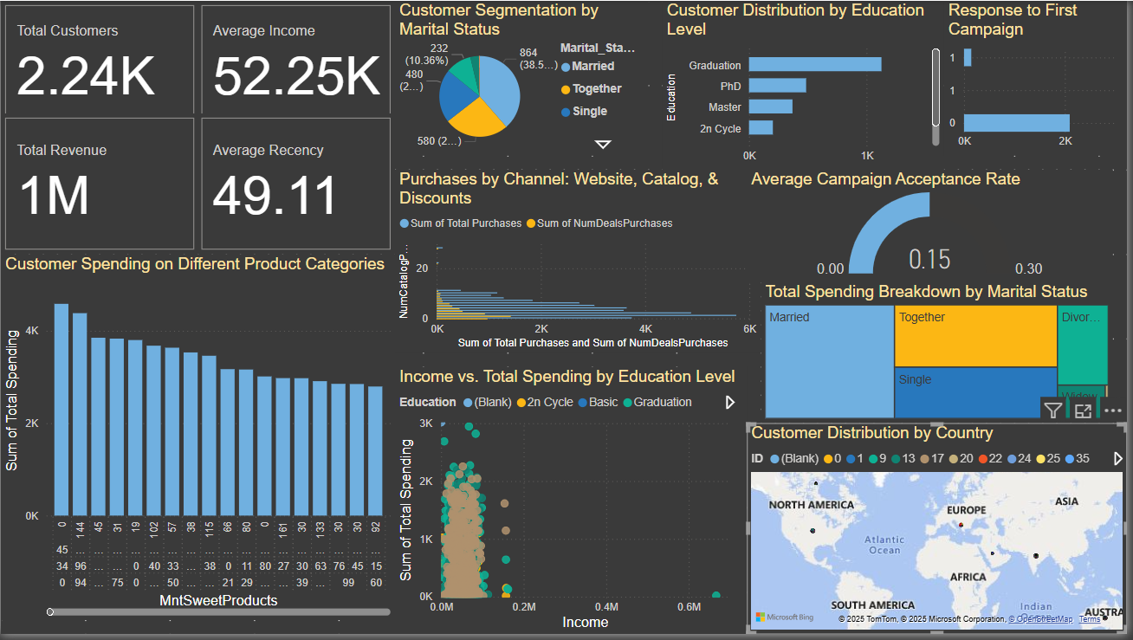

**Understanding Our Customers & Business Trends**

**1️ Quick Overview (Cards)**

Before we dive into the details, here’s a quick snapshot of some key business numbers:

* **Total Customers:** 2,240 people.
* **Average Income:** $52.25K per customer.
* **Total Revenue:** $1M (how much customers have spent overall).
* **Average Recency:** 49 days (meaning, on average, customers last made a purchase 49 days ago—the lower, the better).

**What does this tell us?**  
We’re catering to a mid-to-high-income group with a solid customer base. But the 49-day recency shows that we might need strategies to keep them coming back more often.

**2️ Education Levels – Who Are Our Customers? (Bar Chart)**

This chart shows how many customers fall into different education levels:

* **Graduates** – The biggest chunk (~1,100 customers).
* **Master’s Degree holders** – Second place (~550 customers).
* **PhD holders** – Around 400 customers.
* **2nd Cycle & Basic Education** – The smallest groups (~150–250).

**Key Takeaway:**  
Most of our customers are **well-educated, with the majority being college graduates**. If we ever plan campaigns or promotions, focusing on products that appeal to educated, professional audiences would be smart.

**3️ Marital Status – Who Are We Selling To? (Pie Chart)**

Here’s a breakdown of our customers based on their relationship status:

* **Married:** 38.57% (864 customers).
* **Living Together (but not married):** 25.89% (580 customers).
* **Single:** 10.35% (232 customers).
* **Divorced & Widowed:** Smaller percentage (~15% combined).

**What this means:**  
A big chunk (over 64%) of our customers are either **married or in relationships**, which means we could explore promotions tailored toward families or couples.

**4️ First Marketing Campaign – Success or Flop? (Bar Chart)**

This chart checks how many customers accepted the first marketing campaign:

* **Accepted:** ~2,000 customers.
* **Declined:** ~240 customers.

**Conclusion:**  
This was a **big win**, with **most people accepting the offer**. But the real question is—**did they continue buying after that, or was it just a one-time thing?**

**5️ Where Do Customers Shop the Most? (Clustered Bar Chart)**

This chart compares **where** people prefer to shop:

* **Catalog Purchases:** The most common (5–20 purchases per customer).
* **Total Purchases:** Spread across 0–6K transactions.
* **Discounted Purchases:** Much lower than catalog purchases.

**What’s interesting?**  
People **prefer shopping through catalogs** rather than using discounts. So, instead of running discount-based sales, we might do better by improving and promoting the catalog experience.

**6️ Do Customers Respond to Marketing? (Gauge Chart – Campaign Acceptance Rate)**

* **Campaign Acceptance Rate:** 15%

**The problem?**  
Only **15% of customers respond to campaigns**, which means **85% are just ignoring them**. Something needs to change—maybe making offers more personalized or relevant.

**7️ Who Spends the Most? (Spending by Marital Status – TreeMap)**

* **Married customers spend the most.**
* **Living Together & Single customers spend a decent amount.**
* **Divorced & Widowed customers spend the least.**

**Key Insight:**  
Since **married customers** are the biggest spenders, we should focus more on promotions that appeal to families or couples to increase sales further.

**8️ Where Are Our Customers Located? (Map Chart)**

* **Most of our customers are in North America & Europe.**
* **Very few in Asia, South America, and Australia.**

**What this tells us:**  
Right now, we’re **relying heavily on North America and Europe**. If we want to grow, **expanding into Asia and South America** could be a great opportunity.

**9️ What Are People Buying? (Product Categories – Bar Chart)**

Here’s how customers are spending across different products:

* **Sweet Products:** The most popular (~$4K+ per customer).
* **Other categories (Fish, Gold, Meat, etc.):** Spend ranges between $1K–$4K per customer.

**So, what’s the best-seller?**  
Sweet products **win by a mile**! If we want to push sales further, this category is our best bet.

**10 Does More Income = More Spending? (Scatter Plot – Income vs. Total Spending)**

* Customers earning **$70K+ tend to spend the most**.
* **Graduates & Master’s Degree holders** spend the most as well.

**What this tells us:**  
Higher-income, well-educated customers **are the ones spending the most**. So, premium product pricing and branding should **target this group directly**.

**OBJECTIVES**

1 **Who are the highest spenders?**

* **Married customers.**
* **People with an income over $70K.**
* **Educated professionals (Graduates & Master’s Degree holders).**

2 **What sells the most?**

* **Sweet products lead the way!**
* **Other categories perform moderately.**

3 **How do customers prefer to shop?**

* **Catalog shopping is the #1 choice.**
* **Discounts don’t seem to attract many customers.**

4 **Are marketing campaigns effective?**

* **Not really… Only 15% acceptance.**
* **Time to rethink our marketing strategy and make offers more relevant.**

Our business is doing well, but there are clear areas for improvement. Customers love **catalog shopping**, sweet products are the **best sellers**, and **married, high-income customers** spend the most. The biggest problem? **Our marketing isn’t hitting the mark**—most people ignore campaigns.

If we fix that and expand to new regions, we could **grow even bigger!**